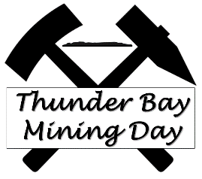

April 1, 2019

Dear Sponsor/Exhibitor,

The 7th Annual Thunder Bay Mining Day is being held on Saturday, June 22, 2019 at Marina Park! It is hosted and organized by volunteers from a variety of local associations who are involved in the mining, exploration and the related supply and service industries in northwestern Ontario. It serves to raise awareness of the importance of these industries in our local economy and in our everyday lives. In the six years since it was first organized, this event has grown in popularity, attracting 400 people in its first year and over 2000 last year.

The Northwestern Ontario Prospectors Association (NWOPA), in conjunction with the Thunder Bay Community Economic Development Commission (CEDC), is once again hosting this high-energy event, which will include a wide variety of exciting demonstrations, interactive activities and mining/exploration exhibits. Partners from industry, government and academia work together to ensure the success of this public education event.

At this time, I would like to ask you to consider exhibiting and/or supporting this event as a sponsor. At the $1000 level, your contribution will provide you with recognition as a premier sponsor on all print materials and digital communications, including the website, as well as on prominent signage at the event.

Secondary sponsorships at the $500 level are also available. At this level, you will receive recognition on print materials and on the website. All donations, regardless of size, are gratefully received and will go directly toward offsetting the substantial costs of Mining Day and ensuring that it continues to be an exciting and important annual event.

We also welcome you to exhibit with a table/booth in our tent or outdoors at Marina Park. As this is a family event, exhibitors are encouraged to provide learning opportunities, such as an interactive activity or game for children.

I have attached a sponsorship/exhibit form for your consideration.

Your support would be greatly appreciated and we look forward to seeing you at Thunder Bay Mining Day 2018. For more information on the event and to view a gallery of pictures from previous Mining Days, please visit www.thunderbayminingday.com

Please feel free to contact me should you have any questions. I appreciate your consideration of our request and hope that you are able to support us in our efforts.

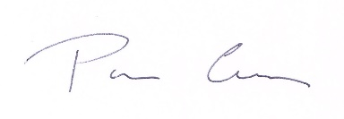
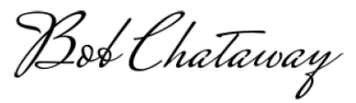
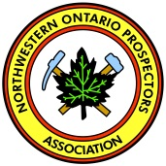
Sincerely,

Bob Chataway & Pam Coles, Co-Chairs
Thunder Bay Mining Day Organizing Committee
E-Mail: tbminingday@gmail.com

Exhibitor/Sponsor Form
Thunder Bay Mining Day, June 22nd, 2019
Exhibitor’s Name_____________________________________________________________
Address___________________________________________________________________________
City_______________________ Province_______________ Postal Code_________
Phone______________________ E-Mail______________________
Contact Person______________________________________
Please indicate (circle) if you require any of the following:
Indoor Outdoor (Size) 4’ X 8’ table Folding Chair* Power Hookup ____________
*Due to a limited number of available chairs we can only offer 1 chair per display. We ask that you bring any additional chairs you will require.
Sponsorship (If Desired):__________________________________________
(Payable by cheque to “NWOPA” e-transfer (treasurer@nwopa.net))
Sponsorship benefits include:
Signage at the event, recognition in the Mining Day program and on the Mining Day website.
Corporate logos should be emailed to: tbminingday@gmail.com

Please send completed documentation by June 7, 2019 to:
NWOPA
PO Box 10124
Thunder Bay ON P7B 6T6
Or e-mail Paul Nielsen at: tbminingday@gmail.com

Thank you for your support!
